# ST.XAVIER’S COLLEGE

# MAITIGHAR, KATHMANDU



**ASSIGNMENT #5**

**Database Management System**

**Submitted By:**

Pratibha Panta

012BSCCSIT028

4th Sem, 2nd Year

**Submitted To:**

______________________

Er. Sanjay Kumar Yadav

Department of Computer Science

Lecturer

Entity Relationship model

**1. What do you mean by Entity- Relationship Diagram? Explain**

Entity relationship model is the process of designing database in terms of entities and relationships among them. An entity is a thing or object in real world that are distinguishable from other object.

Relationship is an association among several entities. Set of all entities of same type is the entity set and similarly set of all relationships of same type is the relationship sets. E-R diagram explains the structural view of the database as a whole.

Eg:

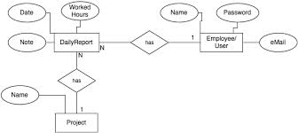

**2. Define entity and give an example.**

An entity is a thing or object in real world that are distinguishable from other object.

Eg. Customer, account, etc.

**3. Explain the different between an entity class and an entity instance.**

"An entity is a person, place, event, or thing about which data is collected. An instance is an occurrence of an entity."

Entities that have the same attributes are grouped in what are best called entity classes.

Entity instance is a single occurrence of an entity type.

**4. Define attribute and its types.**

Attribute is the descriptive property of entity. Set of attributes describe entity set.

Customer=(customer_id, customer_name, customer_city)

Account=account_id, account_holdername, etc

**5. What is derived attributes?**

Attributes whose value can be derived from other related attributes or entities are called derived attributes.   
For eg. If in case of date of birth is given in a certain entity set, then attribute customer’s age can be derived attribute because we can derive age after date of birth is included.

**6. Define relationship and give an example.**

Relationship is an association among two or more entities.

Example: For two entity sets customer and account, we can define relationship set depositor

which associates each customer to their corresponding account he/she has.

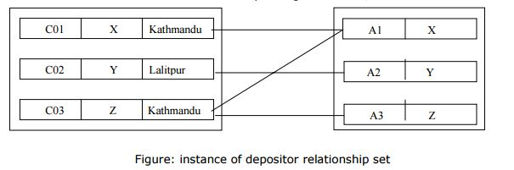

**7. Explain the difference between a relationship class and a relationship instance.**

**8. Define degree of relationship.**

Degree of relationship refers to the number of participating entities in a relationship. If there are two entities involved in relationship then it is referred to as binary relationship. If there are three entities involved then it is called as ternary relationship and so on.

**9. List and give an example of the three types of binary relationships. Draw an E-R diagram**

**for each.**

**10. Define the terms maximum cardinality and minimum cardinality.**

On the other hand, it is the cardinality of relationship that defines the number of instances of one entity as it relates to the number of instances of the other entity. Based on the different combinations between two entities we can have either one-to-one, one-to-many or many-to-many relationship.

**11. Explain the distinctions among the terms primary key, candidate key and super key.**

Primary key

In a relation, it is possible that we can choose distinct set of attributes as a candidate key.

For example: in customer we can choose single attribute {custome_id} or set attributes

{customer_name, customer_city} as candidate key. Candidate key chosen by database

designer for particular relation known as primary key.

Candidate key

The minimal super key called candidate key. That is, candidate key is a super key but its proper

subset is not super key. For example: customer_id is a candidate key in customer relation.

Similarly account_id is a candidate key in account relation.

Super key

A super key is a set of one or more attributes which uniquely identifies an entity in entity set.

For example: in customer relation single attribute customer_id is sufficient to uniquely identify

one customer entity to another. So customer_id is a super key in a customer relation. Since

combination of customer_id and customer_name can also uniquely identifies one customer

entity to another.

**12. What are the main building modules of the entity relationship model? Discuss each one.**

**13. What is composite attributes, when it is used?**

Attribute that can further divide into subparts called composite attribute. For example,

Customer_name in customer entity set is composite attribute since it can be divided into sub

Attributes: customer_fname, customer_mname and customer_lname. Composite attributes

Helps to group related attributes, which makes modeling clearer.

**14. Explain the difference between single-value attributes and simple attributes.**

Attribute that can take only one value in every entry called singled-valued attribute. For

example, attribute customer_name in customer entity set is single-valued attribute since it can

not contain more than one customer name in any entry.

Attribute which cannot be divide into subparts (i.e. into other attributes) called simple

attribute. For example, customer_id in customer entity set is simple attribute, since it can not

divide into sub attributes.

**15. Discuss the difference between a composite key and a composite attribute. How would**

**each indicated in an E-R diagram?**

When a primary key is created from a combination of 2 or more columns, the primary key is called a composite key. Each column may not be unique by itself within the database table but when combined with the other column(s) in the composite key, the combination is unique.

Attribute that can further divide into subparts called composite attribute. For example,

customer_name in customer entity set is composite attribute since it can be divided into sub

attributes: customer_fname, customer_mname and customer_lname. Composite attributes

helps to group related attributes, which makes modeling clearer.

**16. What two courses of action are available to a designer when a multivalued attribute is**

**encountered ?**

**17. Explain the various terms of an E-R model and how are they represented in an E-R**

**model?**

**18. Explain the concept of dependent entities? Give example.**

In relational terms, a child entity that depends on the foreign key attribute for uniqueness is called a dependent entity. For these entities, the foreign key must be a part of the primary key of the child entity (above the line) in order to uniquely define each entity.

**19. What is the difference total and partial participation? Explain.**

The participation of an entity set E in a relationship set R is said to be total if every entities in E

participates in at least one relationship in R. If only some entities in E participate in relationship

in R, then participation of entity set E in relationship set R is said to be partial. The participation

of loan in the relationship set borrower is total but customer entity set in borrower relationship

set is partial since not all customers necessarily take loan from bank, customer may also those

who are only account holder. Such participation constraint can be express by E-R model. We

will discuss it in later section.

**20. What do you mean by mapping cardinalities ? explain various type of cardinalities.**

A mapping cardinality is a data constraint that specifies how many entities an entity can be related to in a relationship set.

Example: A student can only work on two projects, the number of students that work on one project is not limited.

A binary relationship set is a relationship set on two entity sets. Mapping cardinalities on binary relationship sets are simplest.

Consider a binary relationship set R on entity sets A and B. There are four possible mapping cardinalities in this case:

1. one-to-one - an entity in A is related to at most one entity in B, and an entity in B is related to at most one entity in A.

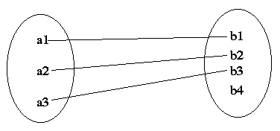

2.one-to-many - an entity in A is related to any number of entities in B, but an entity in B is related to at most one entity in A.

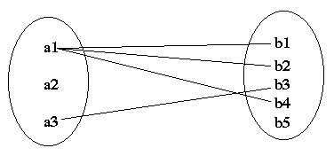

3**.** many-to-one - an entity in A is related to at most one entity in B, but an entity in B is related to any number of entities in A.

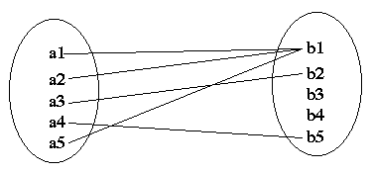

4. many-to-many - an entity in A is related to any number of entities in B, but an entity in B is related to any number of entities in A.

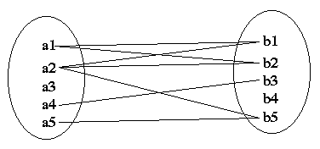

**21. What is the difference between single-value and multivalued attributes? Explain**

**22. Explain the concept of participation constraints.**

**23. Difference the binary relationship with ternary relationship with example.**

**24. Explain the difference between weak and strong entity set.**

**25. Define the components of extended E-R features.**

**26. Define the concept of aggregation. Give two examples of where this concept is useful.**

**27. Explain the distinction between disjoint and overlapping constraints.**

**28. Explain the distinction between total and partial constraints.**

**29. Write short notes on:**

**· Specialization**

**· Generalization**

**· Aggregation**